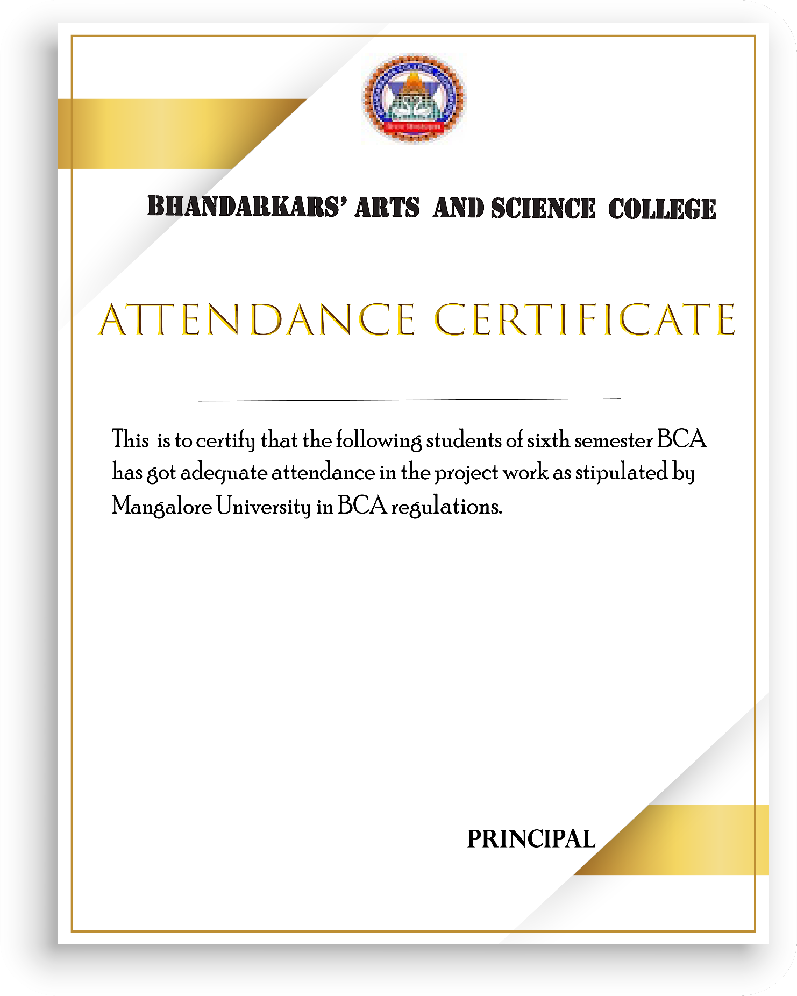

KUNDAPURA-576201

SANJANA S :201231522136

SAPTHAMI CHATRA :201231522226

PREETI JANARDHAN NAIK :201231522213